**Introduction to Project**

**Online Grocery Store (Group-70)**

Nowadays it’s difficult to wander at nearby stores to buy groceries, also because of time constraints we won’t be able to go to store to buy things.

In the current pandemic situation, it’s difficult to go out for shopping purpose.

Currently Purchasing Grocery items has become a tedious job in city due to traffic. Small and medium scale store, have to manage their data about customers, services offered to them. It is difficult for small scale businesses to maintain data for longer time as they are using paper-based system.

We are also solving the problem from customer's end by making ease of choice. They can choose the products from different category and from different brands.

The web based “Online Grocery Store” project is an attempt to stimulate the basic concepts of Grocery Store. The system enables the customer to do the things such as search for Products category wise, choose products based on description and add that product into cart.

The system provides you details about product. If user wants to buy product, he/she must have registered account. The system shows the product that are available or that are in stock, the system displays price, quantity, availability of product to user as well as to employees of store. Here we provided products by category wise that allows customer to choose a particular product easily.

**Technologies Used**

* MySQL (DBMS)
* React- JS (frontend Technology)
* Spring Boot (Backend Technology)

**Use Case Diagrams:**

Administration Function:

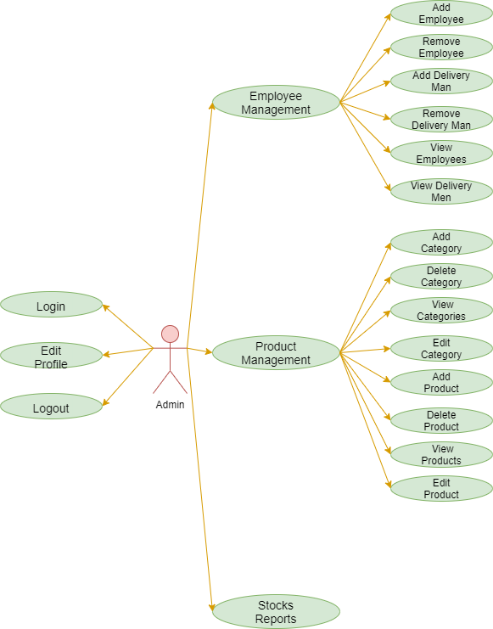

Employee Function:

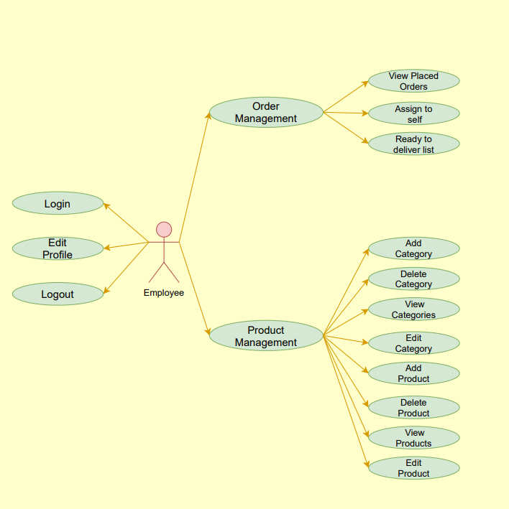

Customer Function:

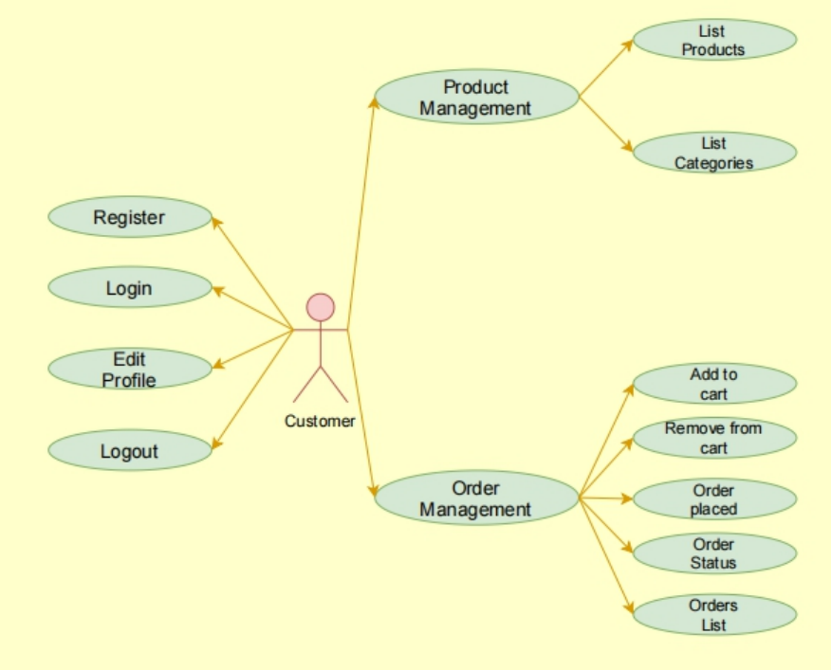

Delivery Function:

